ECA5602- 5g/6g communication
Slot D
K. Nga Sai Nikhil Reddy
192412553

Experiment 7: Analysis of 5G NR Frame Structure and Subcarrier Spacing
.Objective 1:
Code:
clc; clear; close all;
Nsc = 24; % Simplified number of subcarriers
Nsym = 14; % OFDM symbols per slot
grid = zeros(Nsym,Nsc);
% Simplified DL assignment: symbols 1-10
grid(1:10,:) = 1;
% Simplified UL assignment: symbols 11-1
grid(11:14,:) = 2;
figure
imagesc(grid)
grid on
xlabel('Subcarrier Index')
ylabel('OFDM Symbol Index')
title('Simplified 5G NR Time-Frequency Resource Grid')
colorbar
output:
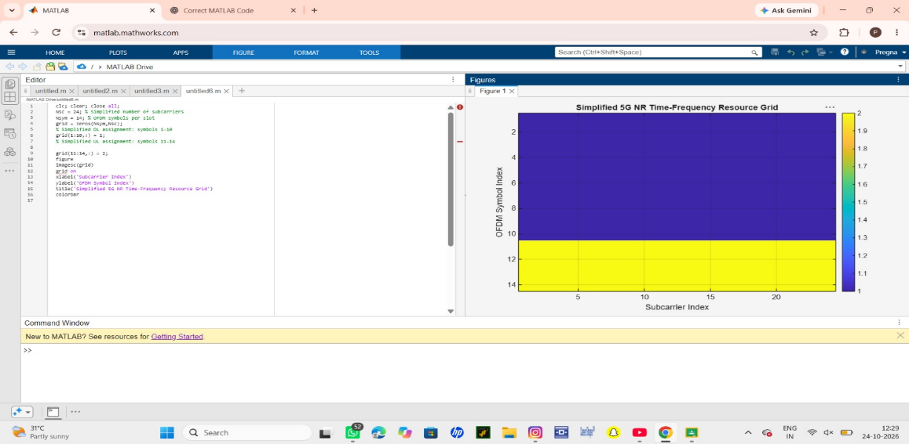

Objective 2
clc; clear; close all;
scs = [15 30 60 120 240]; % kHz
mu = 0:4;
slot = [1 0.5 0.25 0.125 0.0625]; % ms
figure
plot(scs,slot,'o-','LineWidth',2)
grid on
xlabel('Subcarrier Spacing (kHz)')
ylabel('Slot Duration (ms)')
title('5G NR Slot Duration for Different Subcarrier Spacing')
figure
bar(scs)
grid on
set(gca,'XTickLabel',mu)
xlabel('Numerology Index (\mu)')
ylabel('Subcarrier Spacing (kHz)')
title('5G NR Subcarrier Spacing for Different Numerologies')
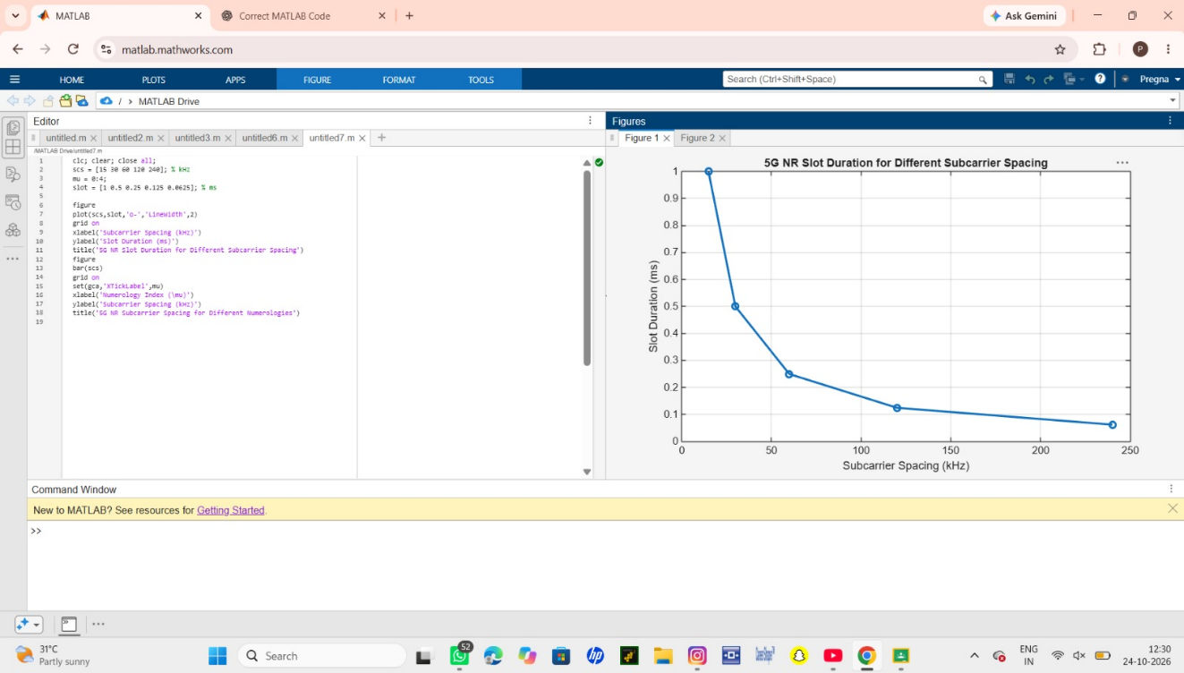

Objective 3:
Code:
clc; clear; close all;
symbols = 1:14;
DL = [1 1 1 1 1 1 1 1 1 1 0 0 0 0];
UL = [0 0 0 0 0 0 0 0 0 0 1 1 1 1];
figure
plot(symbols,DL,'o-','LineWidth',2); hold on
plot(symbols,UL,'s-','LineWidth',2)
grid on
xlabel('OFDM Symbol Index')
ylabel('Allocation Status')
title('Simplified Downlink and Uplink Assignment')
legend('Downlink','Uplink')

output:

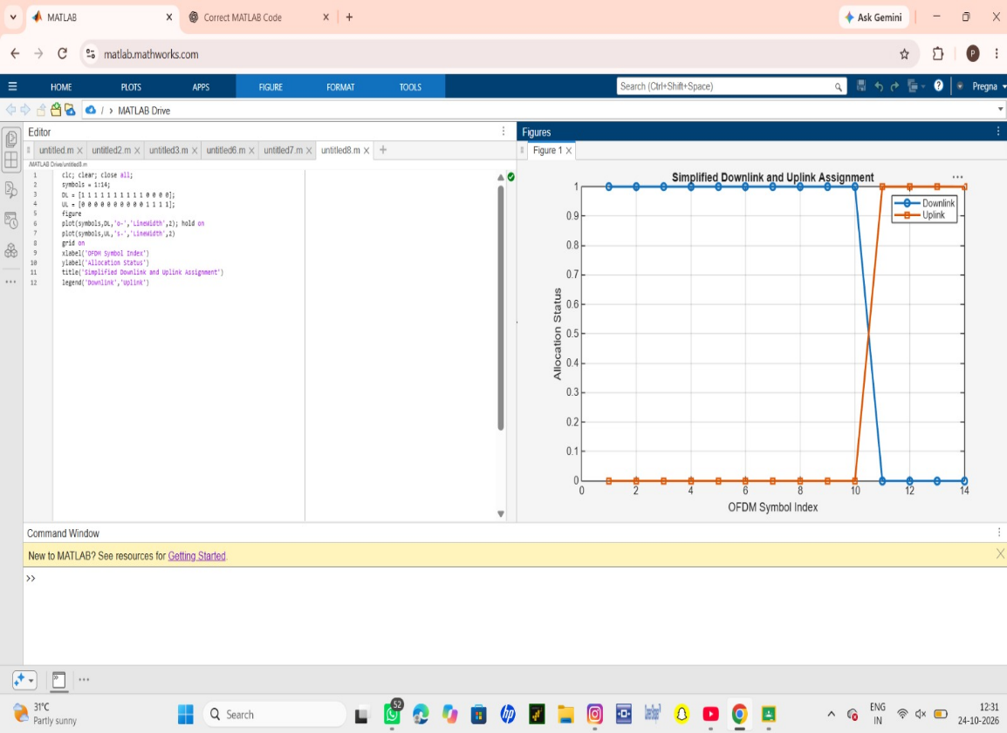
Result
1. A simplified 5G NR resource grid was generated and inspected.
2. The effect of different SCS values on slot duration was analyzed.
3. Basic downlink and uplink resource assignments were represented.
4. The relationship among NR radio resources, gNodeB operation, RAN organization and
RRC was explained.

